+91-8048860168

Maruti International

http://www.marutiinternational.net/

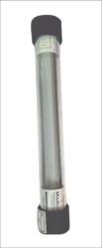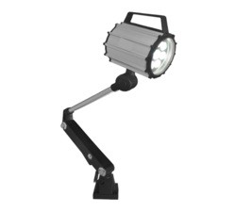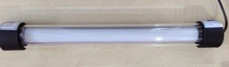We are manufacturers of Machine Lamp, LED Flood Light, LED Street Light, Guide Way Wiper, Electrical Discharge Machine.

About Us

Maruti International established in the year 2005 analyzes as one of the premier manufacturer, exporter and supplier of graded products. We have been famed quality in maintaining our line of products which include Machine Lamp, Electrical Discharge Machine, Guide Way Wiper, LED Street Light, LED Flood Light and Maruti LED Street Light. We offer these products based on client specifications. We have a team of quality analysts to check the quality of our products. We export our products in Africa, Asia, etc. Our products can be customized as per the specifications of the clients. We have a state of art infrastructure facility to manufacture and check the quality of the products on various parameters. These products are widely applauded by our clients for their features like optimum performance, excellent service, efficiency, utility, reliability and durability. Our team keep ourselves abreast with industry standards to meet the changing requirements of our clients in the best possible manner.

LED CNC MACHINE LAMP  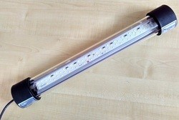  36 W LED CNC Machine LED CNC MACHINE LAMP  Lamp 18 W  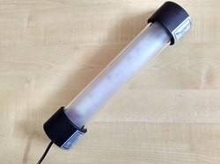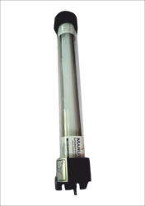  LED CNC Machine Lamp LED CNC Machine Lamp 14w With Diffuser 22W | Our Products

LED ARM MACHINE LAMP  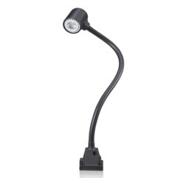  LED Arm Machine Lamp LED Arm Machine Lamp (Long) (flexible)  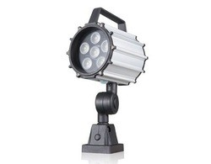  LED Arm Machine Lamp (short) | Our Products

MACHINE LAMP  LED CNC Machine Lamp Milling Machine LED Lamp  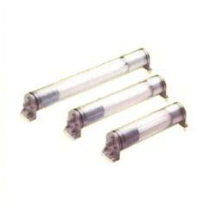  LED Machine Lamp CNC Machine Light | Our Products

LED FLOOD LIGHT  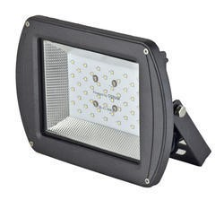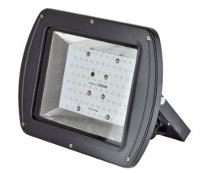  LED FLOOD LIGHT 50W LED Flood Light100w  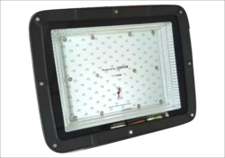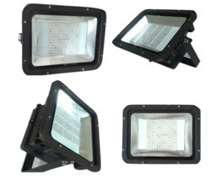  LED Flood Light150w LED FLOOD LIGHT 200W | Our Products

LED STREET LIGHT  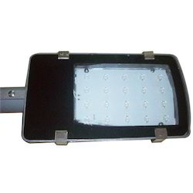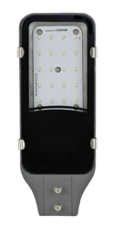  LED Street Light (20W) LED Street Light 24w  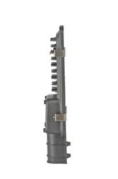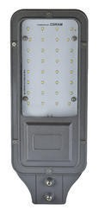  LED Street Lights LED STREET LIGHT 36W | Our Products

LED DOWN LIGHT  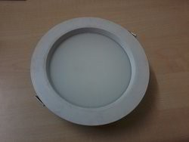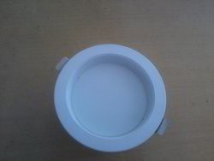  LED Down Light (12 W) LED Down Light 9 W  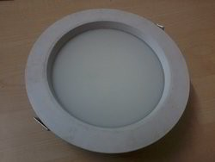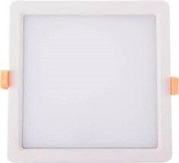  LED Downlight (18 W) Indoor LED Light | Our Products

OTHER PRODUCTS:  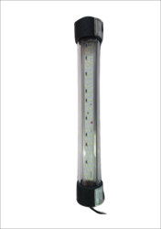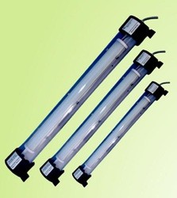  CNC Machine Lamp Work Light CNC Machine  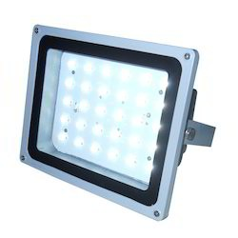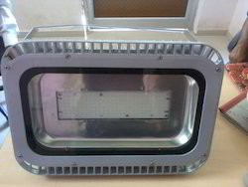  Outdoor LED Flood Light LED Flood Light | Our Products

OTHER PRODUCTS:  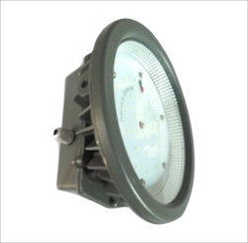  Flood Lights LED HIGHBAY LIGHT 50W  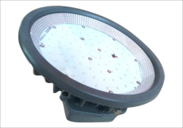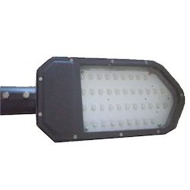  LED HIGHBAY LIGHT 100W 40W LED Street Lights | Our Products

OTHER PRODUCTS:  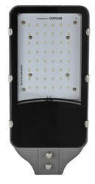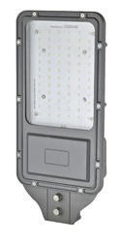  LED Street Light 50w LED Street Light 90w  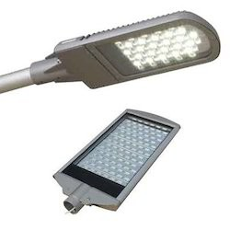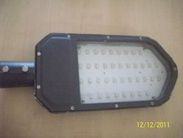  LED Street Light LED Light | Our Products

OTHER PRODUCTS:  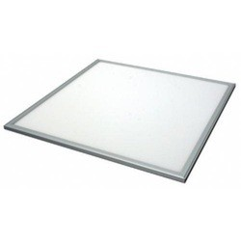  LED Down Lights LED Panel Light  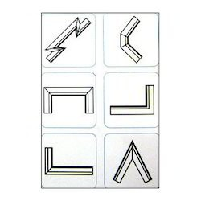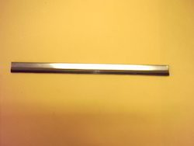  Machine Tool Guide Way Way Wipers Wipers | Our Products

F a c t s h e e t

Year of Establishment : 2005
Nature of Business : Manufacturer Total Number of Employees : Upto 10 People
Major Markets : East Asi a Indi an Subconti nent

CONTACT US
Maruti International

Contact Person: Rajiv Natu

Plot No. 60, Road No. 9, G. I. D. C Manjusar, Savali Vadodara - 391775, Gujarat, India

+91-8048860168
http://marutiinternational.in/

